pennsylvania
LIQUOR CONTROL BOARD

December 15, 2021

Anthony J. Magnotta, Esquire Borough Solicitor
1307 Purdytown Turnpike, Suite A Lakeville, PA 18438
VIA E-MAIL: christina@magnottalaw.com

RE: Borough of Milford Resolution No. 2021-16 Case No. 21-NE-20

Dear Mr. Magnotta:

Please be advised that the Pennsylvania Liquor Control Board ("Board") approved the petition of the Borough of Milford, Pike County ("Borough") on December 15, 2021 in the above-referenced case, for the area designated by the Borough in its petition as the Borough's Historic District, including zoning areas for commercial and limited commercial districts. This area is exempted from compliance with section 493(34) of the Liquor Code, 47 P.S. § 4-493(34), regarding amplified sound for the period commencing December 15, 2021 and ending at 2:00 a.m. on December 15, 2024. The Borough's Noise Ordinance, found in Chapter 198 of the Borough's Codified Ordinances, will be in effect during said period. A copy of the Board's Order and other pertinent documents are enclosed.

Sincerely,

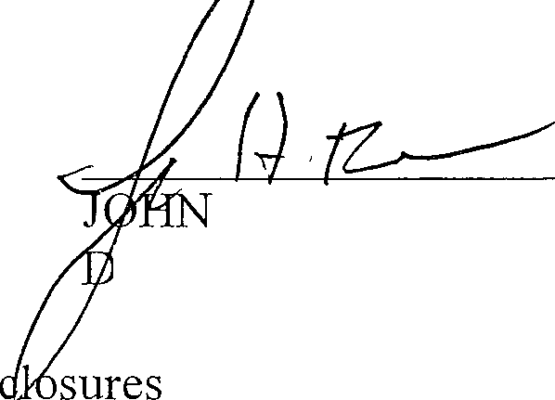RODRIGO J. DIAZ CHIEF CO EL
By:
H. FRAKER
EPUTY CHIEF COUNSEL
En

cc: Pennsylvania State Police Bureau of Liquor Control Enforcement Bureau of Licensing
Kathleen Marzzacco, Esquire Licensees

Chief Counsel
401 Northwest Office Building I Harrisburg, PA 17124 I 717.783.9454 IF 717.787.8820 j lcb.state.pa.us

PLCB-1039 09-15

BEFORE THE PENNSYLVANIA LIQUOR CONTROL BOARD

In Re: Borough of Milford Resolution No. 2021-16 Case No. 21-NE-20
Municipal Application for Exemption from Statute Regarding Amplified Sound

The Board, after giving careful consideration to all of the facts established at the hearing, and in the exercise of its discretion, makes the following Order:

ORDER

AND NOW, December 15, 2021, it is ordered and decreed that the municipal application for exemption from section 493(34) of the Liquor Code, 47
P.S. § 4-493(34), regarding amplified sound filed on behalf of the Borough of Milford, Pike County ("Borough"), pursuant to Resolution No. 2021-16, is hereby approved for the area described in its petition as the Borough's Historic District, including zoning areas for commercial and limited commercial districts.

This approval shall commence on December 15, 2021 and shall end on December 15, 2024 at 2:00 a.m.

PENNSYLVANIA LIQUOR CONTROL BOARD

^{i} /', . {·.,

BY Chairman
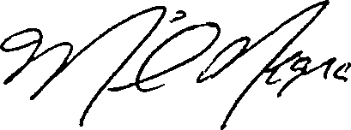

Member
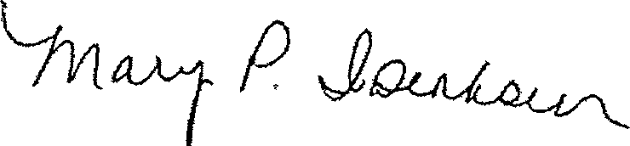

Member

ATTEST:

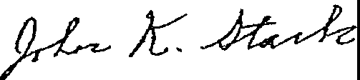

Secretary

! pennsylvania
LIQUOR CONTROL BOARD

December 15, 2021

C & S Restaurant Enterprises, Inc. t/a Johns of Arthur Avenue
115 7th Street
Milford, PA 18337

RE: Borough of Milford Resolution No. 2021-16 Case No. 21-NE-20

Dear Licensee:

This is to advise you that the Pennsylvania Liquor Control Board ("Board"), at its meeting of December 15, 2021, approved the application of the Borough of Milford, Pike County ("Borough"), in the above-referenced case for a period commencing December 15, 2021 and ending at 2:00 a.m. on December 15, 2024. As a Board licensee in the area designated by the Borough in its petition, you are exempted from compliance with section 493(34) of the Liquor Code, 47 P.S. § 4-493(34), regarding amplified sound for the duration of said period. The Borough's Noise Ordinance, found in Chapter 198 of the Borough's Codified Ordinances, will be in effect during said period. Copies of the pertinent documents are enclosed.

Sincerely,

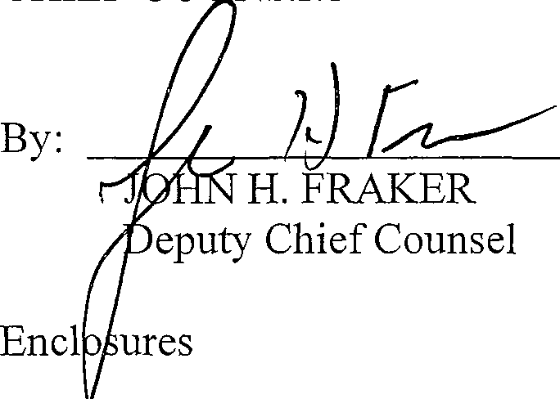
RODRIGO J. DIAZ CHIEF CO SEL

cc: Pennsylvania State Police, Bureau of Liquor Enforcement Bureau of Licensing
Anthony J. Magnotta, Esquire, Solicitor Kathleen Marzzacco, Esquire

Chief Counsel
401 Northwest Office Building I Harrisburg, PA 17124 I 717.783.9454 IF 717.787.8820 I lcb.state.pa.us

PLCB-1039 09-15

t/a Hotel Fauchere 401 Broad Street
Milford, PA 18337

RE: Borough of Milford Resolution No. 2021-16 Case No. 21-NE-20

Dear Licensee:

This is to advise you that the Pennsylvania Liquor Control Board ("Board"), at its meeting of December 15, 2021, approved the application of the Borough of Milford, Pike County ("Borough"), in the above-referenced case for a period commencing December 15, 2021 and ending at 2:00 a.m. on December 15, 2024. As a Board licensee in the area designated by the Borough in its petition, you are exempted from compliance with section 493(34) of the Liquor Code, 47 P.S. § 4-493(34), regarding amplified sound for the duration of said period. The Borough's Noise Ordinance, found in Chapter 198 of the Borough's Codified Ordinances, will be in effect during said period. Copies of the pertinent documents are enclosed.

Sincerely,

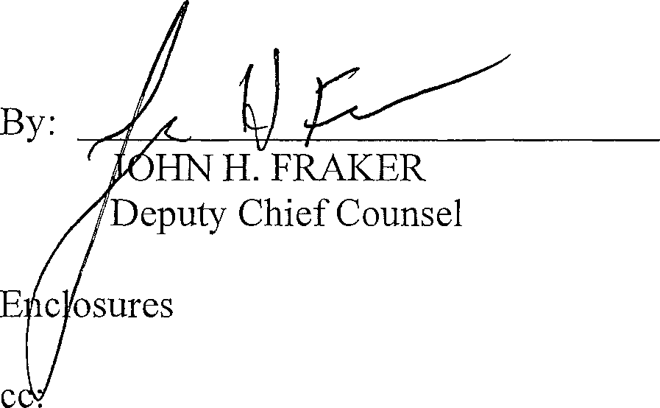
RODRIGO J. DIAZ CHIEF COUNSEL

Pennsylvania State Police, Bureau of Liquor Enforcement Bureau of Licensing
Anthony J. Magnotta, Esquire, Solicitor Kathleen Marzzacco, Esquire

Chief Counsel
401 Northwest Office Building I Harrisburg, PA 17124 I 717.783.9454 I F 717.787.8820 ! lcb.state.pa.us

PLCB-1039 09-15

t/a Jive
319 Broad Street
Milford, PA 18337

RE: Borough of Milford Resolution No. 2021-16 Case No. 21-NE-20

Dear Licensee:

This is to advise you that the Pennsylvania Liquor Control Board ("Board"), at its meeting of December 15, 2021, approved the application of the Borough of Milford, Pike County ("Borough"), in the above-referenced case for a period commencing December 15, 2021 and ending at 2:00 a.m. on December 15, 2024. As a Board licensee in the area designated by the Borough in its petition, you are exempted from compliance with section 493(34) of the Liquor Code, 47 P.S. § 4-493(34), regarding amplified sound for the duration of said period. The Borough's Noise Ordinance, found in Chapter 198 of the Borough's Codified Ordinances, will be in effect during said period. Copies of the pertinent documents are enclosed.

Sincerely,

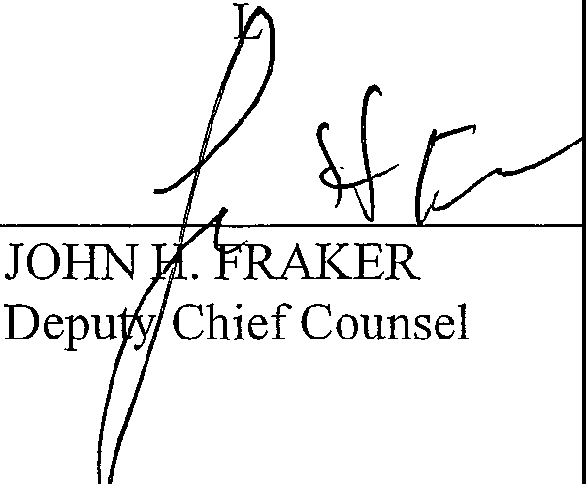
RODRIGO J. DIAZ CHIEF COUNSE

By:

Enclosures

cc: Pennsylvania State Police, Bureau of Liquor Enforcement Bureau of Licensing
Anthony J. Magnotta, Esquire, Solicitor Kathleen Marzzacco, Esquire

Chief Counsel
401 Northwest Office Building I Harrisburg, PA 17124 I 717.783.9454 I F 717.787.8820 I lcb.state.pa.us

t/a Laurel Villa Country Inn 210 2nd Street
Milford, PA 18337

RE: Borough of Milford Resolution No. 2021-16 Case No. 21-NE-20

Dear Licensee:

This is to advise you that the Pennsylvania Liquor Control Board ("Board"), at its meeting of December 15, 2021, approved the application of the Borough of Milford, Pike County ("Borough"), in the above-referenced case for a period commencing December 15, 2021 and ending at 2:00 a.m. on December 15, 2024. As a Board licensee in the area designated by the Borough in its petition, you are exempted from compliance with section 493(34) of the Liquor Code, 47 P.S. § 4-493(34), regarding amplified sound for the duration of said period. The Borough's Noise Ordinance, found in Chapter 198 of the Borough's Codified Ordinances, will be in effect during said period. Copies of the pertinent documents are enclosed.

Sincerely,

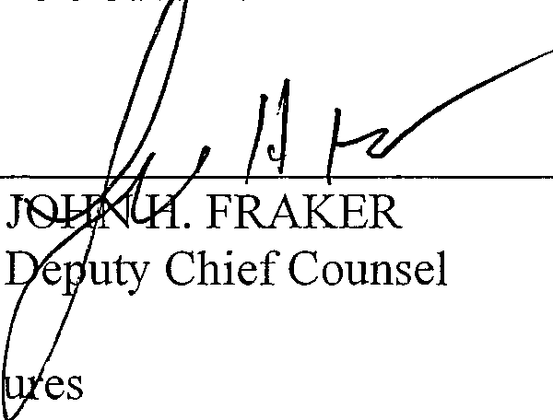
RODRIGO J. DIAZ CHIEF COUN EL

By:

Enclos

cc: Pennsylvania State Police, Bureau of Liquor Enforcement Bureau of Licensing
Anthony J. Magnotta, Esquire, Solicitor Kathleen Marzzacco, Esquire

Chief Counsel
401 Northwest Office Building I Harrisburg, PA 17124 I 717.783.9454 J F 717.787.8820 J lcb.state.pa.us

Log Tavern Brewing Company t/a Log Tavern Brewing
309 East Harford Street Building 2
Milford, PA 18337

RE: Borough of Milford Resolution No. 2021-16 Case No. 21-NE-20

Dear Licensee:

This is to advise you that the Pennsylvania Liquor Control Board ("Board"), at its meeting of December 15, 2021, approved the application of the Borough of Milford, Pike County ("Borough"), in the above-referenced case for a period commencing December 15, 2021 and ending at 2:00 a.m. on December 15, 2024. As a Board licensee in the area designated by the Borough in its petition, you are exempted from compliance with section 493(34) of the Liquor Code, 47 P.S. § 4-493(34), regarding amplified sound for the duration of said period. The Borough's Noise Ordinance, found in Chapter 198 of the Borough's Codified Ordinances, will be in effect during said period. Copies of the pertinent documents are enclosed.

Sincerely,

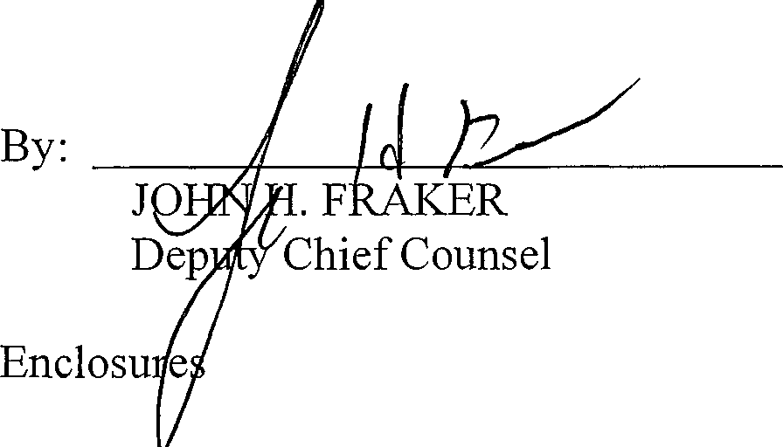
RODRIGO J. DIAZ CHIEF COUNS L

cc: Pennsylvania State Police, Bureau of Liquor Enforcement Bureau of Licensing
Anthony J. Magnotta, Esquire, Solicitor Kathleen Marzzacco, Esquire

Chief Counsel
401 Northwest Office Building I Harrisburg, PA 17124 J 717.783.9454 I F 717.787.8820 J lcb.state.pa.us

PLCB-1039 09-15

Milford Beer Bar, Inc. 204 West Harford Street Milford, PA 18337

RE: Borough of Milford Resolution No. 2021-16 Case No. 21-NE-20

Dear Licensee:

This is to advise you that the Pennsylvania Liquor Control Board ("Board"), at its meeting of December 15, 2021, approved the application of the Borough of Milford, Pike County ("Borough"), in the above-referenced case for a period commencing December 15, 2021 and ending at 2:00 a.m. on December 15, 2024. As a Board licensee in the area designated by the Borough in its petition, you are exempted from compliance with section 493(34) of the Liquor Code, 47 P.S. § 4-493(34), regarding amplified sound for the duration of said period. The Borough's Noise Ordinance, found in Chapter 198 of the Borough's Codified Ordinances, will be in effect during said period. Copies of the pertinent documents are enclosed.

Sincerely,

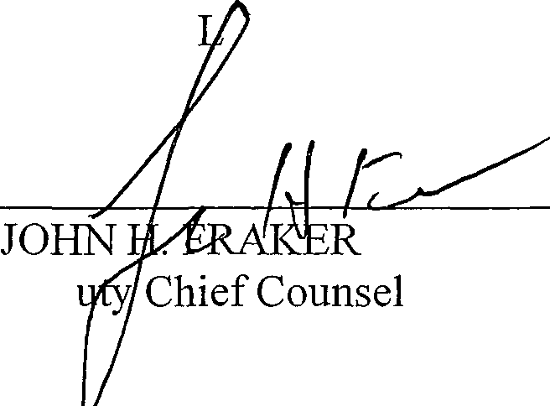
RODRIGO J. DIAZ CHIEF COUNSE

By:

Dep Enclosures
cc: Pennsylvania State Police, Bureau of Liquor Enforcement Bureau of Licensing
Anthony J. Magnotta, Esquire, Solicitor Kathleen Marzzacco, Esquire

Chief Counsel
401 Northwest Office Building I Harrisburg, PA 17124 I 717.783.9454 I F 717.787.8820 I lcb.state.pa.us

Q L Ventures, LLC t/a Tom Quick Inn 411 Broad Street
Milford, PA 18337

RE: Borough of Milford Resolution No. 2021-16 Case No. 21-NE-20

Dear Licensee:

This is to advise you that the Pennsylvania Liquor Control Board ("Board"), at its meeting of December 15, 2021, approved the application of the Borough of Milford, Pike County ("Borough"), in the above-referenced case for a period commencing December 15, 2021 and ending at 2:00 a.m. on December 15, 2024. As a Board licensee in the area designated by the Borough in its petition, you are exempted from compliance with section 493(34) of the Liquor Code, 47 P.S. § 4-493(34), regarding amplified sound for the duration of said period. The Borough's Noise Ordinance, found in Chapter 198 of the Borough's Codified Ordinances, will be in effect during said period. Copies of the pertinent documents are enclosed.

Sincerely,

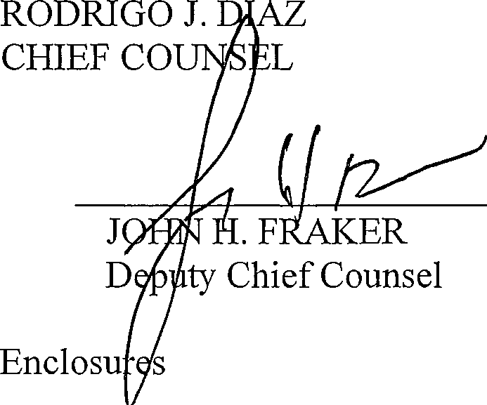
By:
cc: Pennsylvania State Police, Bureau of Liquor Enforcement Bureau of Licensing
Anthony J. Magnotta, Esquire, Solicitor Kathleen Marzzacco, Esquire

Chief Counsel
401 Northwest Office Building I Harrisburg, PA 17124 I 717.783.9454 I F 717.787.8820 I lcb.state.pa.us

Red Brick Tavern
t/a Historic Dimmick Inn 101 East Harford Street Milford, PA 18337

RE: Borough of Milford Resolution No. 2021-16 Case No. 21-NE-20

Dear Licensee:

This is to advise you that the Pennsylvania Liquor Control Board ("Board"), at its meeting of December 15, 2021, approved the application of the Borough of Milford, Pike County ("Borough"), in the above-referenced case for a period commencing December 15, 2021 and ending at 2:00 a.m. on December 15, 2024. As a Board licensee in the area designated by the Borough in its petition, you are exempted from compliance with section 493(34) of the Liquor Code, 47 P.S. § 4-493(34), regarding amplified sound for the duration of said period. The Borough's Noise Ordinance, found in Chapter 198 of the Borough's Codified Ordinances, will be in effect during said period. Copies of the pertinent documents are enclosed.

Sincerely,
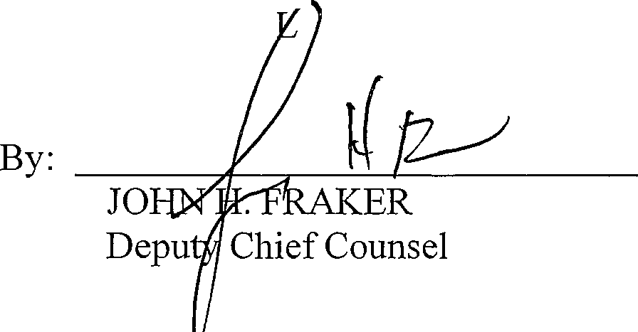
RODRIGO J. DIAZ CHIEF COUNSE
Enclosures

cc: Pennsylvania State Police, Bureau of Liquor Enforcement Bureau of Licensing
Anthony J. Magnotta, Esquire, Solicitor Kathleen Marzzacco, Esquire

Chief Counsel
401 Northwest Office Building I Harrisburg, PA 17124 I 717.783.9454 I F 717.787.8820 J lcb.state.pa.us

Simonet Sisters, Inc.
t/a Waterwheel Cafe and Bakery 150 Water Street
Milford, PA 18337

RE: Borough of Milford Resolution No. 2021-16 Case No. 21-NE-20

Dear Licensee:

This is to advise you that the Pennsylvania Liquor Control Board ("Board"), at its meeting of December 15, 2021, approved the application of the Borough of Milford, Pike County ("Borough"), in the above-referenced case for a period commencing December 15, 2021 and ending at 2:00 a.m. on December 15, 2024. As a Board licensee in the area designated by the Borough in its petition, you are exempted from compliance with section 493(34) of the Liquor Code, 47 P.S. § 4-493(34), regarding amplified sound for the duration of said period. The Borough's Noise Ordinance, found in Chapter 198 of the Borough's Codified Ordinances, will be in effect during said period. Copies of the pertinent documents are enclosed.

Sincerely,

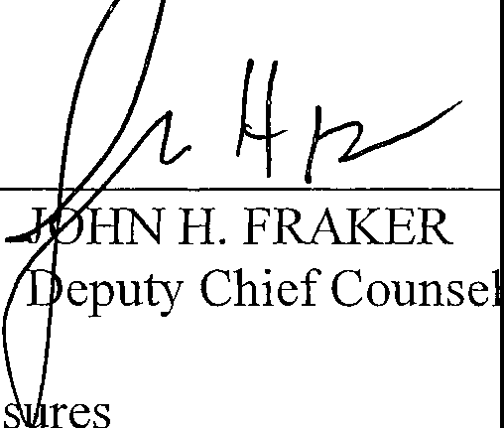
RODRIGO J. DIAZ CHIEF CO SEL

By:

Enclo

cc: Pennsylvania State Police, Bureau of Liquor Enforcement Bureau of Licensing
Anthony J. Magnotta, Esquire, Solicitor Kathleen Marzzacco, Esquire

Chief Counsel
401 Northwest Office Building I Harrisburg, PA 17124 I 717.783.9454 IF 717.787.8820 j lcb.state.pa.us

Pl \.A-1019 09-15

Zhang Mao, Inc.
206 West Harford Street Milford, PA 18337

RE: Borough of Milford Resolution No. 2021-16 Case No. 21-NE-20

Dear Licensee:

This is to advise you that the Pennsylvania Liquor Control Board ("Board"), at its meeting of December 15, 2021, approved the application of the Borough of Milford, Pike County ("Borough"), in the above-referenced case for a period commencing December 15, 2021 and ending at 2:00 a.m. on December 15, 2024. As a Board licensee in the area designated by the Borough in its petition, you are exempted from compliance with section 493(34) of the Liquor Code, 47 P.S. § 4-493(34), regarding amplified sound for the duration of said period. The Borough's Noise Ordinance, found in Chapter 198 of the Borough's Codified Ordinances, will be in effect during said period. Copies of the pertinent documents are enclosed.

Sincerely,

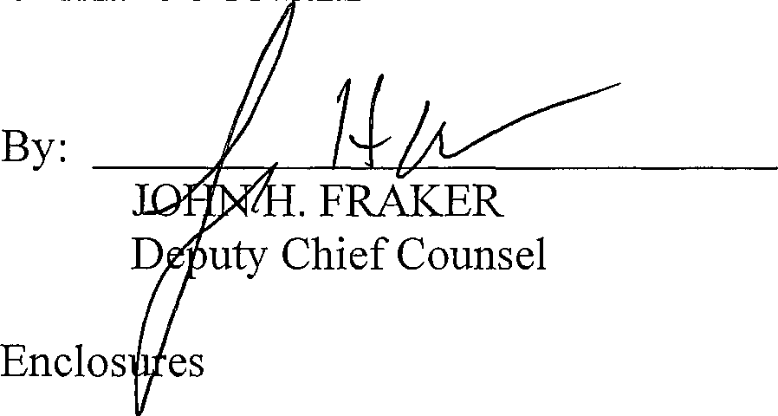
RODRIGO J. DIAZ CHIEF COUN EL

cc: Pennsylvania State Police, Bureau of Liquor Enforcement Bureau of Licensing
Anthony J. Magnotta, Esquire, Solicitor Kathleen Marzzacco, Esquire

Chief Counsel
401 Northwest Office Building I Harrisburg, PA 17124 I 717.783.9454 J F 717.787.8820 J lcb.state.pa.us

I HISTORY: Adopted by the Boreugh Council of tlw Borough of iv'.i!rord 6-,1-19/3 by Ord. No. 191, approved 6·'1- l 97::0: ( Ch. 7r.t of'
;he ·1:!79 C ode); amencled in its entirety at time of adoption of Code ( see Ch. l, Genenl Provisions, Art. I). Subseque;11: 3rncndrnents noted vv!·1c-re ,ipplicable.]

GENERAL REFERENCES
Amusement and entertainment - See Ch. 88. Dog control - See Ch. 94, Art. I.
Nulsances - See Ch. 205. Zoning- SeeCh. 312.

§ 198-1 Title.
This chapter shall be known and cited as the "Noise Control Ordinance" of Milford Borough, Pike County, Pennsylvania.

§ 198-2 Legislative authority.
This chapter is adopted under the authority and provisions of the Milford Borough Council ordinances.

§ 198-3 Purpose.
The purpose of this chapter is to establish an effective means of regulating and controlling loud and offensive sound and noise within Milford Borough to:

A. Promote the health, safety and general welfare for residents and visitors; and

8. Protect the interest of local businesses while providing reasonable regulations.

§ 198-4 Unreasonably loud and/or disturbing noise prohibited.
It shall be unlawful for any person or persons to make, permit, continue, or cause to be made or to create any unreasonably loud and/or disturbing noise in the Borough. Noise of such character, intensity and duration as to be detrimental to the health, safety or welfare of any reasonable person of ordinary firmness and sensibilities in the vicinity is prohibited.

- In determining whether a noise is unreasonably loud and/or disturbing, the following definitions shall apply:

DISTURBING
Noise which is perceived by a person of ordinary firmness and sensibilities as interrupting the normal peace and calm of the area, neighborhood, or vicinity.

UNREASONABLY LOUD
Noise which is substantially incompatible with the time and location where created to the extent that it creates an actual or imminent interference with peace and good order.

- In determining whether a noise is unreasonably loud and/or disturbing, the following factors incident to such noise are to be considered based on the totality of circumstances surrounding a particular determination:

  - Time of day;

  - Proximity to residential structures;

  - Whether the noise is recurrent, intermittent, or constant;

  - Volume and intensity;

(s) Whether the noise is enhanced in volume or range by any type of electronic or mechanical means;

- Whether the noise is related to the normal operation of a business or other labor activity; and

- Whether the noise is subject to being controlled without unreasonable effort or expense to the creator thereof,

https://ecode360.com/32404276 1/4

- The outdoor day-night average sound level -(DNL) in decibels at the property line shall not exceed the levels as outlined in the attached table. In the investigation of a violation, the responding official of the Borough shall estimate DNL using the a hand held decibel level meter. Should the test indicate a DNL exceeding the prescribed decibels, the officer shall notify the owner and any aggrieved party of his findings and the potential violation. He shall also recommend appropriate abatement measures. Should a subsequent investigation still indicate a problem, the officer shall determine such average sound level by taking no less than three measurements with a decibel meter, all of which shall occur within 72 hours but no less than 15 minutes apart.

Land Use Category
Residential, public space, open space or institutional

Commercial or business
Time
8:oo a.m. to 8:oo p.m. Monday through Saturday
11:00 a.m. to 8:oo p.m. Sunday and legal holidays
8:oo p.m. to 8:oo a.m. Monday through Saturday
8:oo p.m. to 11:00 a.m. Sunday and legal holidays
8:oo a.m. to 8:oo p.m. Monday through Thursday
8:oo a.m. to 9:00 p.m. Friday and Saturday
11:00 a.m. to 8:oo p.m. Sunday and legal holidays
8:oo p.m. to 8:oo a.m. Monday through Thursday
9:00 p.m. to 8:oo a.m. Friday and Saturday
8:oo p.m. to 11:00 a.m. Sunday and legal holidays
Sound Level Limit
65dBA

50 dBA

7odBA

6odBA

§ 198-5 Exempted noises.
The following noises are exempt from this chapter:

- Noises of safety signals, warning devices, emergency pressure valves, factory steam whistles and all mechanical and electronic church bells or chimes.

- Noises resulting from any authorized emergency vehicle when responding to any emergency call or acting in time of emergency.

- Approved special events as defined in Chapter 88 to include concerts, band concerts, block parties, church carnivals or other performances or similar activities publicly or privately sponsored and presented in any public or private. space outdoors, provided that such activities do not occur between the hours of 8:oo p.m. and 8:oo a.m.

- Noise from lawn mowers, weed trimmers, edging machines, leaf blowers or other similar small-engine yard maintenance equipment, properly equipped according to manufacturer's specifications, and used between 8:oo a.m. and 8:oo p.m., with the exception of Sundays, which will be between 11:00 a.m. and 5:00 p.m.

- Musical accompaniment/noise associated with any event held in recognition of a community celebration of national, state or county events or public festivals.

- Snow removal equipment.

https://ecode360.com/32404276 2/4

- Municipal and utility services. Sounds resulting from the repair or replacement of any municipal or utility installation in or about the public right-of-way.

§ 198-6 Noises prohibited.
The following noises are prohibited:

- Noise or sounds that are substantially incompatible with the time and location where created to the extent that it creates an actual or imminent interference with peace or good order.

- Noise that is perceived by a person of ordinary and reasonable sensibilities as interrupting the normal peace and calm of an area or neighborhood, particularly during the hours of 8:oo p.m. and 8:oo a.m.

- Dogs or any other constrained animals that, by frequent or habitual howling, yelping, barking or otherwise, cause loud noises and produce seriously annoying disturbance to any person or to the neighborhood for a period of 10 minutes continuously and unnecessarily, or intermittently for a period of 30 minutes or more.

- Operating or permitting the operation of any automobile, motorcycle, dirt bike, go-cart, recreational vehicle, remote control vehicle, or other vehicle that engages in jackrabbit starts, spinning tires, racing engines, or other operations, including, without limitation, operating an overloaded or out of repair vehicle which creates unreasonably !oud or disturbing noise so as to disturb the comfort and repose of any person of normal sensibilities in the vicinity.

- Knowingly permitting the occurrence or emanation of any of the foregoing specifically enumerated violations of this chapter on property owned, possessed, or used, in whole or in part, by any person or entity shall be a violation of this chapter.

§ 198-7 Noise complaint procedure.
In the event any person has reasonable grounds for believing that any provision of this chapter is being violated, he may make a report thereof to the Milford Police Department or Zoning Code Enforcement Officer, which shall investigate the alleged violation. lf any such investigation reveals a violation, the investigating officer has the authority to cause a written complaint to be made and may issue a citation for a civil penalty, and/or may obtain other enforcement measures as allowed in this chapter.

§ 198-8 Enforcement; violations and penalties.
Any individual who is found in violation of this chapter may be subject to a civil penalty. The amount of such civil penalty shall be assessed as described below. Each day the violation continues shall be considered a separate offense and therefore, such continuing violation may be subject to multiple civil penalties as described below.

- Compliance order.

  - Upon making a determination that a person is in violation of this chapter, Milford Borough may issue a compliance order to the person in violation of this chapter. The compliance order shafl notify the violator of the violation in writing. Such order shall identify the circumstances giving rise to the violation, including the times, dates and places of the violation. Such notification shall further identify the action which is necessary to comply with this chapter. Such order shall state that if the violator does not comply within a reasonable time, not to exceed 15 days, the individual will be subjected to a civil penafty. If circumstances exist such that the violator cannot come into compliance within 15 days, Milford Borough may grant an extension of time commensurate with the magnitude of the violation. The compliance order shall further state that failure to comply with the terms of the compliance order will subject the violator to a civil penalty and shall further state the amount of said civil penalty.

  - Any person who violates or permits a violation of this chapter shall, upon being found liable therefor, pay a fine of not more than $600, plus court costs and reasonable attorneys' fees incurred by the Borough in the enforcement proceedings. If the penalty is not paid, the Borough shall initiate a civil action for collection in accordance with the Pennsylvania Rules of Civil Procedure. Each day a violation exists shall constitute a separate offense, and each section of this chapter that is violated shall also constitute a separate offense. In addition to or in lieu of enforcement under this section, the Borough may enforce this chapter in equity in the Court of Common Pleas of Pike County.

https://ecode360.com/32404276 3/4

§ 198-9 Effective date; severability; conflicting provisions.
- Effective date of chapter. This chapter shall take effect immediately upon its adoption by the Milford Borough Council, and shall amend and supersede the previously existing noise control regulations ordinance, existing prior to this chapter's adoption.

- Severability. If any provision or provisions of this chapter shall be deemed by a court of law having jurisdiction over such matters to be unenforceable, invalid, or unconstitutional for any reason, such declaration shall not affect the validity of the chapter as a whole, or any part thereof that is not specifically declared to be.

- Conflict of laws or chapter provisions. Whenever the regulations of this chapter conflict with each other, or with the requirements of another statute, the more restrictive standard shall govern.

https://ecode360.com/32404276 4/4

The boundary lines for the proposed exempted noise area encompasses the Historic District of Milford Borough to include the zoning areas of the Commercial and limited Commercial Districts.
From the entrance to the Borough heading northwest on Harford Street at River Road on both sides of Harford Street. The zone lots on the southwest side to 7th Street and includes the section to Mill Street extending to Sawkill Creek and the Milford Township Line. This zone extends four blocks from 7th to 9th Streets between Harford Street and Chestnut Alley.
On the southeast side of Harford, the zone extends to Peach Alley where the Limited Commercial zone starts at 4th Street to Peach Alley ending at Blackberry Alley. From Blackberry Alley to Elderberry Alley· on Harford includes the intersection or Harford and Broad Streets
The Commercial district continues northeast on Broad Street between Elderberry and Blackberry Alleys to Cherry Alley. It continues the southeast side of Broad Street to Blac_kberry Alley ending at the Borough line at Bennet Street.

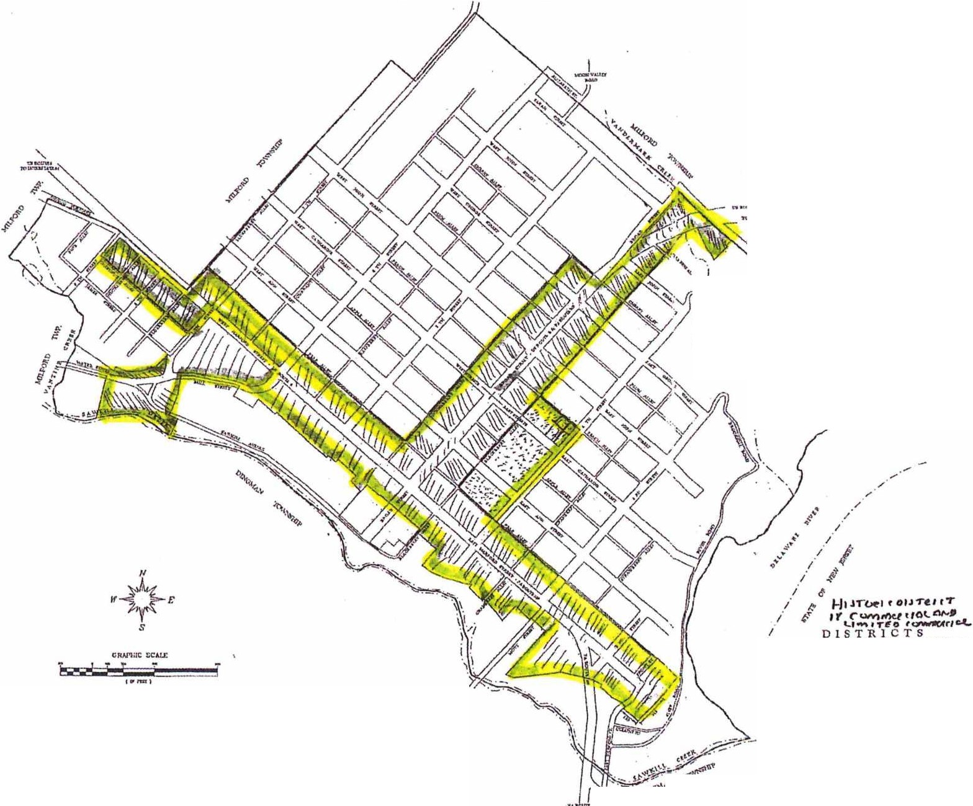
MILFORD*BOROUGH
PIKE COUNTY PENNSYLVANIA
OFFICAL WNING MAP
DATDI• ,_,M'l'>.J- ll1"1Sll)JU:n:1,"""
, .. ...
·-
I
I
_\,_.,........-·.-.. ,.
I
I
I
I
i
_I I I
D RESIOEN'llAl.
\_
I
COMMl:!RCIAL
LO.UllD
COMMERCIAL
:=.:;;.c.:::=:c°:::!::.::'Po";:;:::::t:.:--.:..=:'"'K?
gL--r<ctr=<T -l>'ffll1""_0<.IW ,.""'1(J"JIIM:fCll<,111,.U. "ffUatt"tl111'-
a,m1....,.,.TOtlOlO<>•:tur<,Wnu,..,,._,. _
:..,- :=• ':'":.-. "::=ro":.:::;::_:,i:::: .,=•
•• t,,,_/._ -

,ii'
LEGEND
- • - )<UN1CIPA1. 00UNIJAK'(
-·····-S'I1U!A.\{
l..OTUNE
-•uou.,,. ,,., f<Y'lmo&ne"""""""''"""wrnn;n."l!ai:-.
cn,m,,......,,..-.•.c._....r...,,,....,,..,.",.","t.".".-.1..'C_,lMf'""u'H,o•1.,1..,,.-,....a,.Jna1•.i".,"•"".fMU.Jf.•"c1o1.:..u.,,.•.• _-n-,.,n.·.1u1.>ati,,
·· ;=···-·
1t WOODLANDDESIGNASSOCIATES INC.
,tv,, l'l,\NWJJIS,t,'ffl.U&I
""="':::"-IEIJOOt:ll!N,glW!lllltl,at'fi.,,a,,auo.u.,_,

